Turning in iPad and Mac Laptop
Are you retiring, transferring or resigning? As you know, when leaving your school, you'll need to leave your iPad and laptop at the school or they will need to be given to the Technology department at the District office. There are a few housekeeping issues you need to take care of on both the iPad and Mac Laptop before turning them back in to your principal.
Teachers leave iPad with their principal or the district office when retiring or leaving the district. The iPad kit contains the items listed below. All items need returned.
iPad: 4 items  - iPad -*Reset to factory settings  - USB cable  - Power adapter  - iPad Cover | 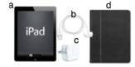
Computer: 4 items  - laptop  - Charging cord  - Laptop bag (if you were given one.) | 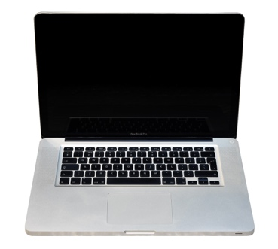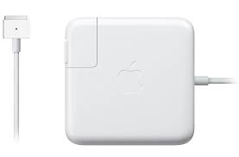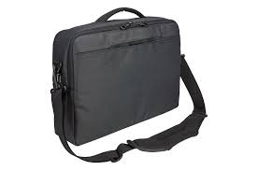

How to Backup your iPad and Reset to Factory Settings:
If a teacher wishes to recover their iPad data on another iPad in the future, they need to ensure that they have an iCloud or Itunes backup and that it is up to date. If they do not wish to recover their iPad data in the future, they may simply erase all content and settings before turning in your iPad.
How to back up to iCloud:  - Tap settings>icloud>Storage & backup  - Tap Backup Now  - Step by step instructions can be found here http://support.apple.com/kb/HT1766 | 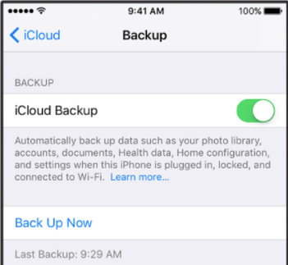
How to backup to iTunes:  - Connect your iPad to your computer.  - In iTunes, choose File>Devices>Backup or  - Right click (control click) iPad in device list and choose Backup  Step by step instructions can be found here http://support.apple.com/kb/HT1766 | 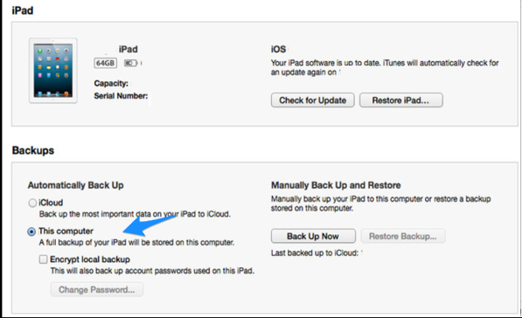
How to erase all content and settings:  - To remove all settings and information from the iPad go to Settings>General>Reset>Erase all Content and Settings  - You may be prompted to enter you’re apple ID and password | 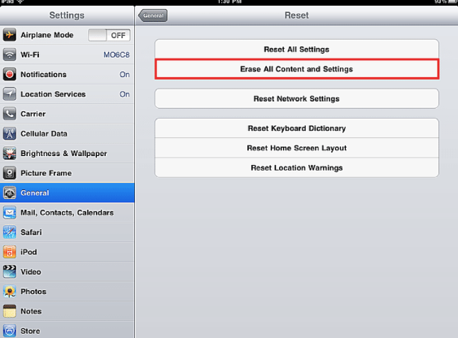
To ensure your iPad has be erased, turn it on. The screen should look like one of the images to the right | 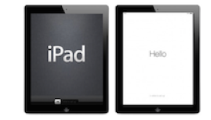
iPad: Reset to factory settings*
- Open the Settings App
- Open iTunes and App Store
- Click on your name and then sign out
- In Settings tap General
- Scroll to the bottom and tap RESET
- Tap on Erase All Content and Settings
- Tap on Erase iPad
- Confirm
- Enter your passcode if you have one
****Failure to follow these steps makes reassignment of the iPad extremely difficult.****
Signing out of iTunes and iCloud on your Macbook Pro:
Teachers need to sign out of iTunes and iCloud on their Mac laptop before turning it into the principal when retiring or leaving the school district.
Sign out of iTunes:  - Open iTunes  - From the menu, Account-SignOut | 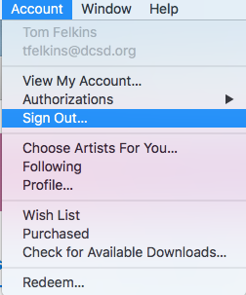
Sign out of iCloud:  - Open System Preferences  - Click on iCloud-SignOut | 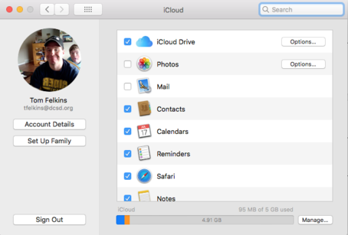

***You do not need to reset your computer. The tech dept. will erase it for you.***

